Greenhorn Mountain Veterans Association 2021 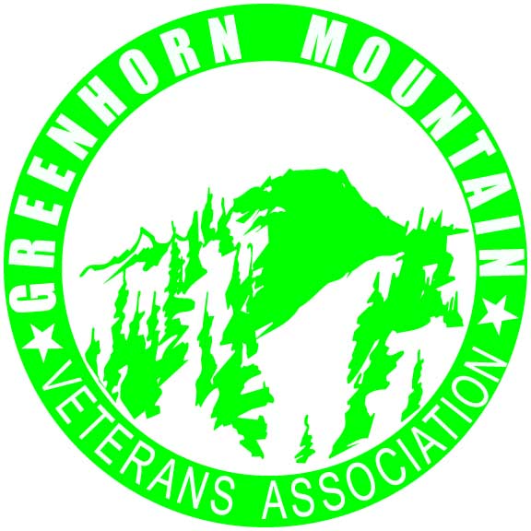

Mutton Busting Rules and Regulations

1) Only children aged 4-7 are eligible to participate. Proof of age must be provided at the time of sign-up.
2) The maximum weight limit for eligibility is 55 pounds, fully clothed. Weight will be determined by weigh-in at the rodeo grounds. Due to the safety concerns of the stock, there will be no exceptions to this rule.
3) All contestants will be provided with a helmet and safety vest at the time of the competition.
4) Only the contestant and one parent/Guardian will be provided with a general admission ticket to the performance.
5) All participants will be given a Mutton Busting Award and gift bag.
6). Entry fee per contestant is $20, Payable to the GMVA
7) Liability waiver must be fully completed.
8) All photos of the event become the property of the GMVA and may be used in promotion of the Glennville Rodeo.
9) Only one parent is allowed to accompany contestant into the arena.

