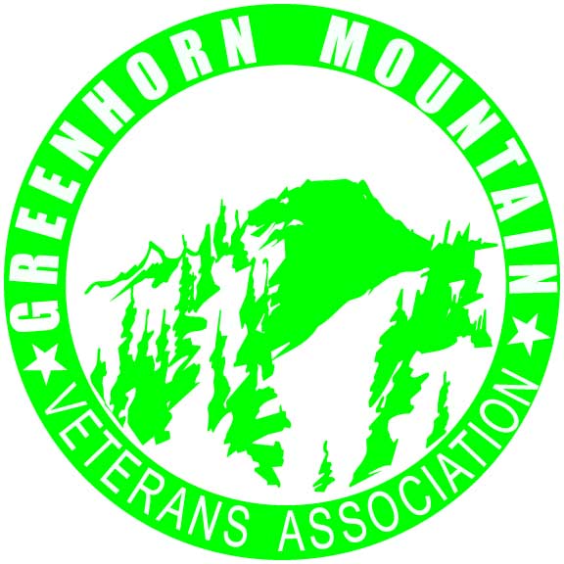

Release of Liability

Greenhorn Mountain Veterans Association
Mutton Busting

I, the undersigned, wish to participate in the Greenhorn Mountain Veterans Association event on June 13, 2021. I understand that during portions of this event I will be in close proximity to one or more horses and sheep under circumstances which may expose me to some risk of injury, because of the nature of horses, sheep the facility, and the activities in which I or my child) will be engaged.

In consideration of the Greenhorn Mountain Veterans Association allowing my participation in this event, I, on behalf of myself, and my heirs, administrators, personal representatives, assigns and children and spouse, if any, do hereby agree to hold harmless, release and discharge The Greenhorn Mountain Veterans Association, which includes its officers, directors, members, agents, representatives, affiliates and insurers, of and from all claims, demands, causes of action and legal liability whether known or unknown, anticipated or unanticipated, due to the ordinary negligence of Greenhorn Mountain Veterans Association. I shall not bring any claims, demands, legal actions or causes of action against Greenhorn Mountain Veterans Association for any damage or loss due to bodily injury, death or property damage arising out of my participation in this event.

____________________________________ ______________________
Signature of Participant Date

____________________________________ ______________________
Signature of Parent or Guardian Date
(If participant is a minor.)

